Handout no. 4

|  |  |
| --- | --- |
| **Name** | Ahmad Bandesha, Faizan Azam, Muhammad Asad |
| **Reg. No** | 2019-EE-373, 2019-EE-381, 2019-EE-383 |
| **Marks/Grade** |  |

**EXPERIMENT # 4**

**Analysis of multivariable power system using Fast Decoupled method**

**Objective:**

At the end of this lab session students will be able to

* To design Power system operations in in Power World Simulator.
* To observe power flow in power System.

**Introduction:**

In any practical power system, operating in steady state condition, there is strong interdependence between active power (P) and bus voltage angle (δ) and between reactive powers (Q) and bus voltage (V), whereas couplings between P-V and Q-δ are relatively weak. This weak-coupling effect may be neglected without introducing much inaccuracy in the load flow solution. This is known as 'decoupled load flow.

The fast decoupled power flow method is a very fast and efficient method of obtaining power flow problem solution. In this method, both, the speeds as well as the sparsity are exploited. This is actually an extension of Newton-Raphson method formulated in polar coordinates with certain approximations which result into a fast algorithm for power flow solution. This method exploits the property of the power system where in MW flow-voltage angle and MVAR flow-voltage magnitude are loosely coupled.

By using fast decoupled method, active and reactive power can be calculated by using these expression**:**

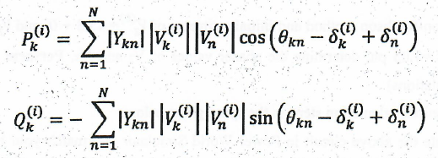

**Task #01:**

A three-bus, three-line system has been shown in Figure. Each line has series impedance of (0.02+0.1j) p.u. and shunt admittance of j0.04 p.u. in 100 MVA base. Obtain line flows, losses and bus voltages using FDLF method. Also obtain real and reactive power generation at bus-1 and reactive power generation at bus-2. (Attach the results of software simulation with this manual).

|  |  |  |  |  |  |
| --- | --- | --- | --- | --- | --- |
| **Bus no.** | **Pd** | **Qd** | **Pg** | **Qg** | **V** |
| 1 | 1 | 0.5 | - | - | 1.03+j0 |
| 2 | 1.5 | 0.75 | 0 | 0 | 1.03+j0 |
| 3 | 1 | 0.2 | 0.5 | - | 11.01 |

**Circuit diagram:**

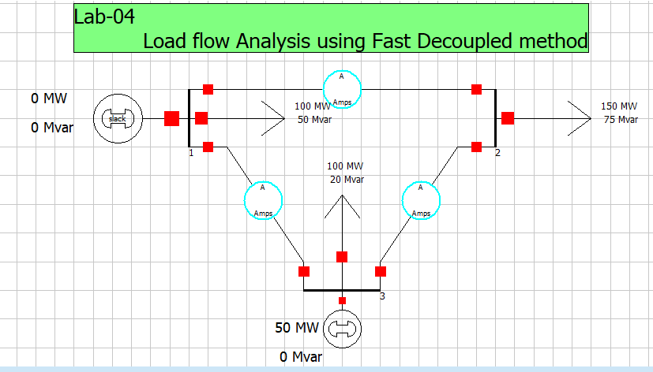**Figure 1: show the one line diagram of power system**

Using PWS

* Draw the one-line diagram in PWS.
* In the Run Mode, go to Tools →→Solve → Single Solution Fast Decoupled. This will give you the final result of the bus voltages after performing all the iterations.
* To view the mismatch vector in PWS go to Case Information → Solution Details → Mismatches. Corroborate your theoretical result with t s mismatch vector. Note you may have calculated the mismatch vector in per units out PWS displays the result in physical units. So you may need to accommodate the multiplying factor.
* To view the Jacobian matrix in PWS go to Case Information → Solution Details → Power Flow Jacobian. Corroborate your theoretical result with this Jacobian matrix.
* You can also import this Jacobian matrix into Matlab. Go to Application button and select Save Ybus or Jacobian.
* To check your results iteration by iteration, go to Tools → Simulator Options → Common Options → Check 'Do Only for One Iteration Now repeat the above step to get results for each iteration.
* While doing single iterations you will hear warning sound until the solution converges.
* The detailed results of each iteration can be viewed through log in the Tools selection.

**Software Simulations:**

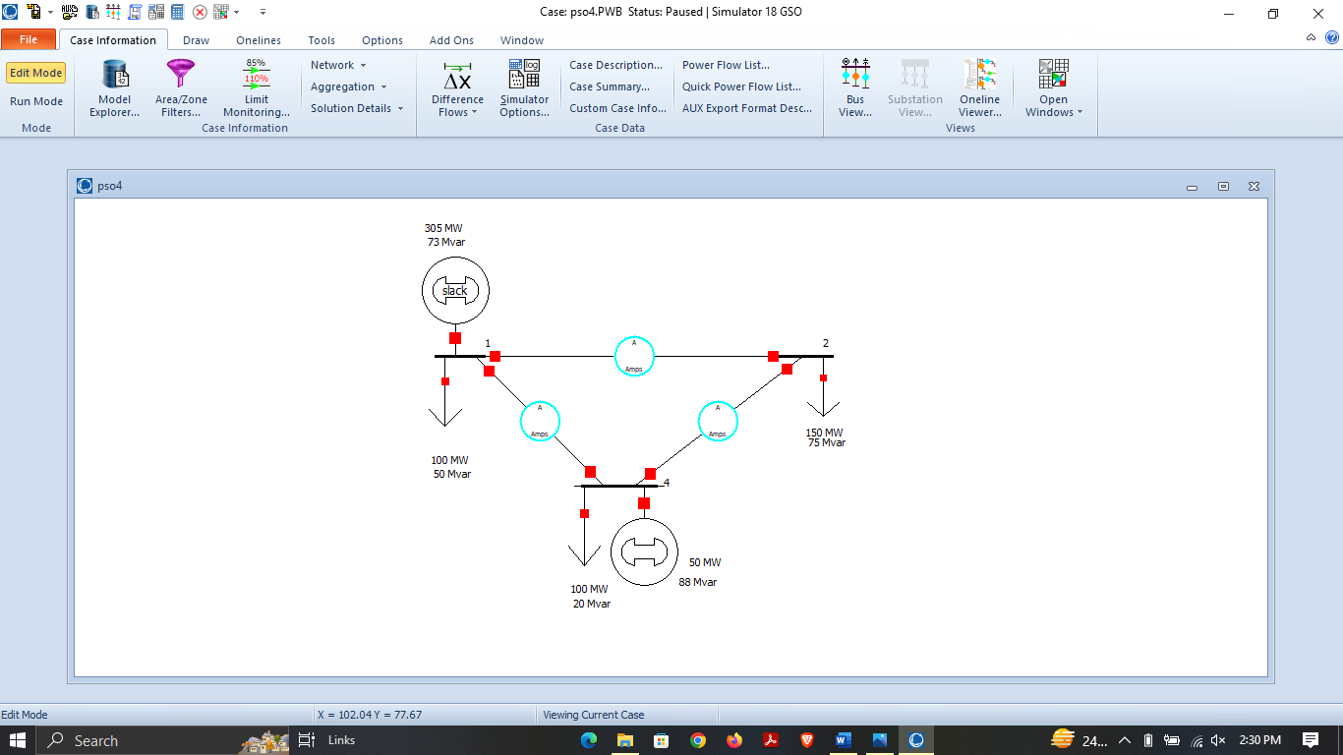

**Figure 4.1:** **Three Bus Power System in Edit Mode**

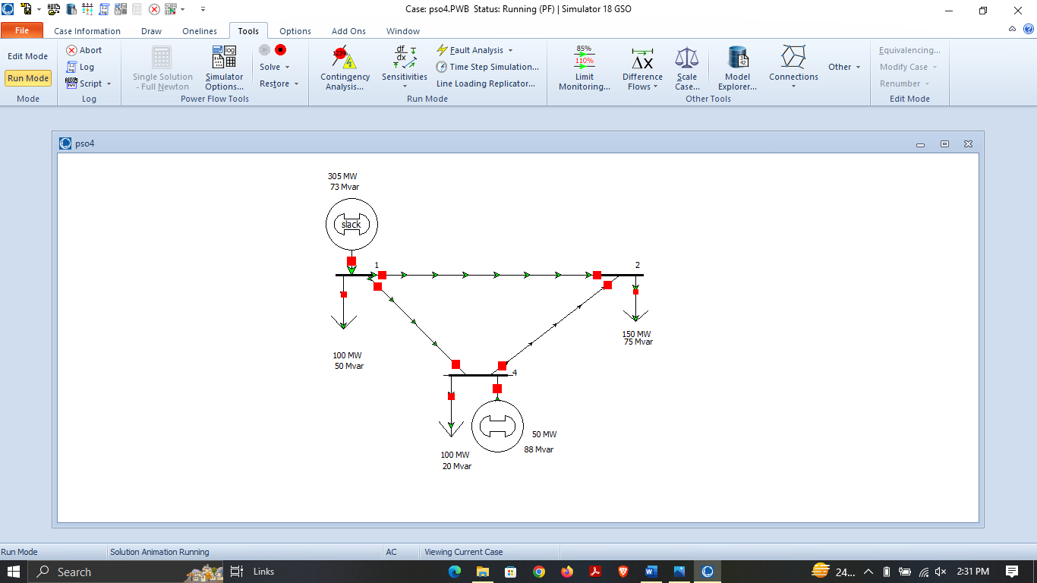

**Figure 4.2: Three Bus Power System in Run Mode**

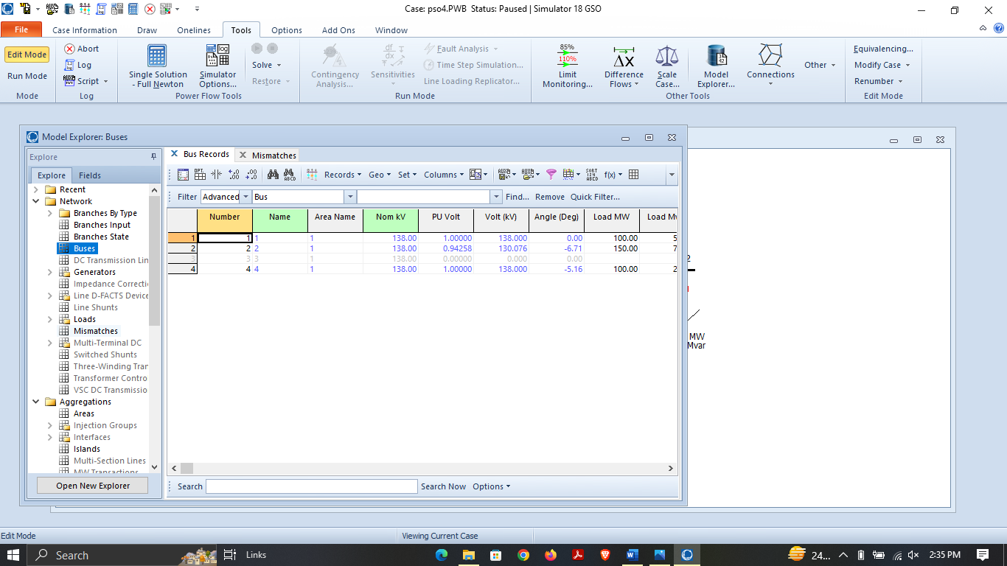

**Figure 4.3:** **Characteristics of three bus power system network**

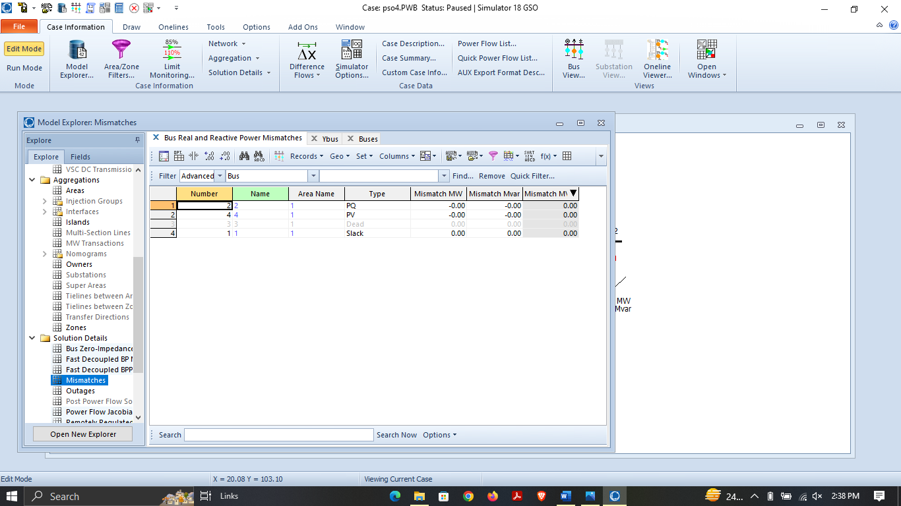

**Figure 4.4: Mismatches**

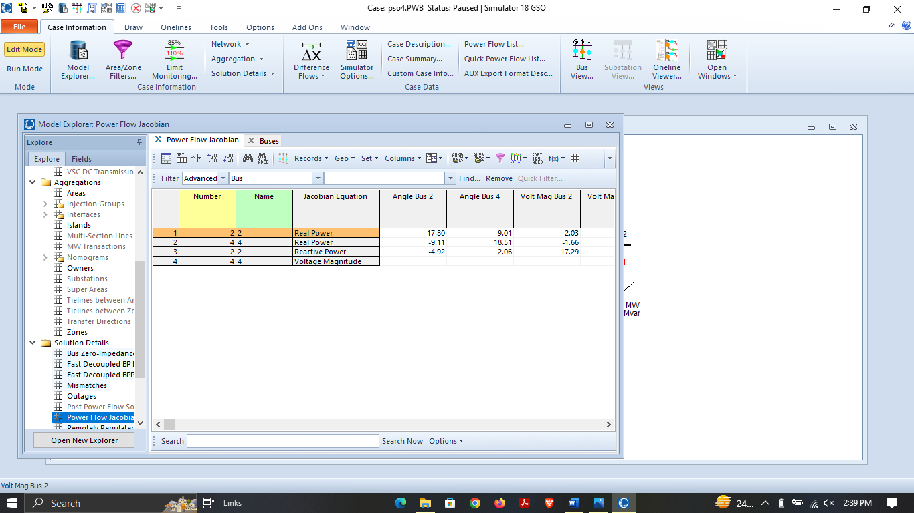

**Figure 4.5: Jacobian Matrix of three Bus System**

**Fast decoupled BP matrix:**

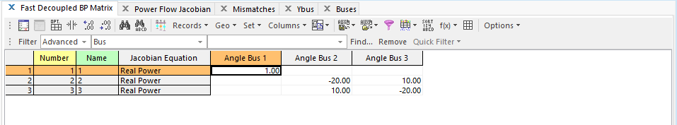**Figure 4.6: show the B prime matrix**

**Fast decoupled BPP matrix:**

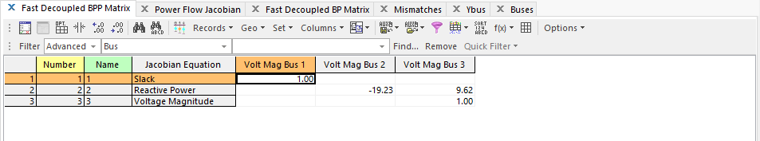**Figure 4.7: show the B double prime matrix**

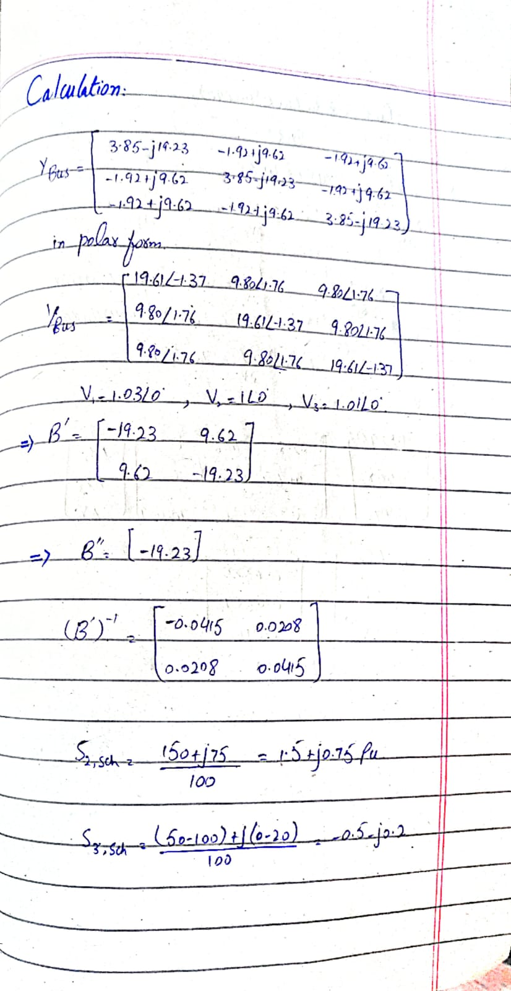**Mathematical Calculations:**

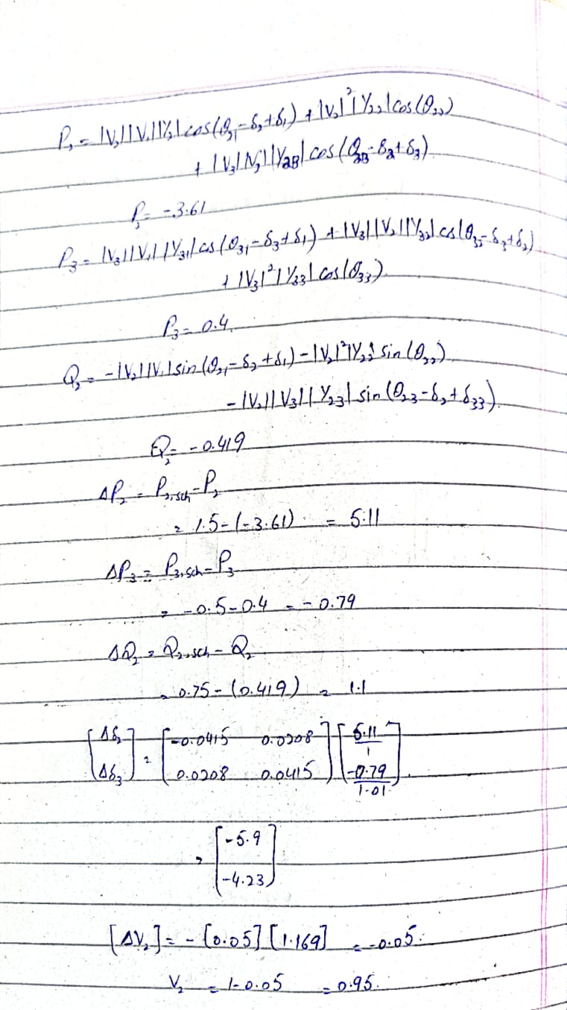

* **Comparison Table:**

|  |  |  |  |  |  |
| --- | --- | --- | --- | --- | --- |
| **No. of iterations** | **Calculations** | | **PWS** | |  |
| **Voltages (pu)** | **Angle** | **Voltages (pu)** | **Angle** |
| 1st Iteration | 1.03748 | -2.08 | 0.96 | -2.6 |
| 2nd Iteration | 1.00131 | -2.3411 | 1 | -2.10 |

**Table: 3.1 For Bus 2**

|  |  |  |  |  |
| --- | --- | --- | --- | --- |
| **No. of iterations** | **Calculations** | | **PWS** | |
| **Voltages (pu)** | **Angle** | **Voltages (pu)** | **Angle** |
| 1st Iteration | 1.03079 | 0.8458 | 0.98 | 1.17 |
| 2nd Iteration | 1.03 | 1.3879 | 1.03 | 1.37 |

**Table: 3.2 For Bus 3**

**Comments and Observations:**

By using this iterative method, I can say that:

The fast decoupled method is power flow algorithm developed by Stott and Alsac [FD]. The method builds on a series of very clever simplifications and the decoupling of the Jacobian matrix of the canonical Newton-Raphson algorithm to yield the fast-decoupled method. The assumptions on voltage magnitudes, angles, and r/x ratios necessary for decoupling the network in the conventional FDPF are eliminated. This method is simple, insensitive to r/x ratios of the distribution lines, and uses a constant Jacobian matrix

The biggest advantage of Fast Decoupled Load Flow (FDLF) method over the conventional Newton-Raphson method is the short computation time for large power systems which is achieved by the reduced size of Jacobian matrix. The fast decoupled load flow method gives an approximate load flow solution because it uses fixed number of iterations. Accuracy depends on the power mismatch vector tolerance.

And we also observed that when we assume series R+Xj then reactive power of the generator gets increased and when Shunt Bj is introduced then Generator’s reactive power gets reduced.